Test the performance of the data object(Skip List,SortedSet)
Test 1: Use BenchmarkDotNet to perform benchmarking and compare the performance differences among the three data structures: SkipList, and SortedSet.The comparison was conducted with both 100,000 and 1,000,000 users, and the results showed that SkipList delivered the best performance.
The results as follows:
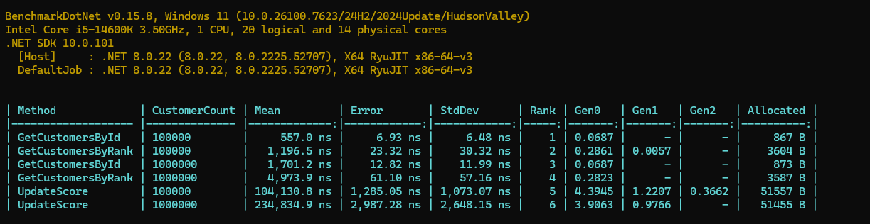
Conclusion: A skip list is a space-time trade-off that uses probabilistic multi-level indexing to ensure efficient search times.

Test the performance difference between SortedSet and SkipList under identical conditions:

Initialize with 5 million records

100 task,each performing 100 operations.
Test 1:Write-only
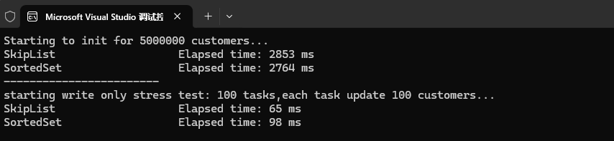

Test 2:30% for read,70% for write
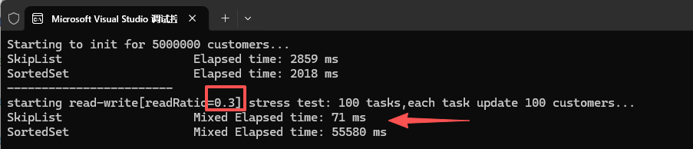
Test 3:50% for read,50% for write
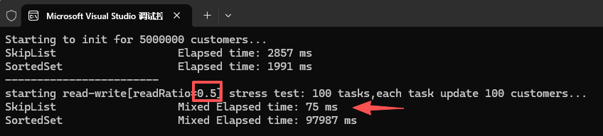
Test4:70% for read,30% for write
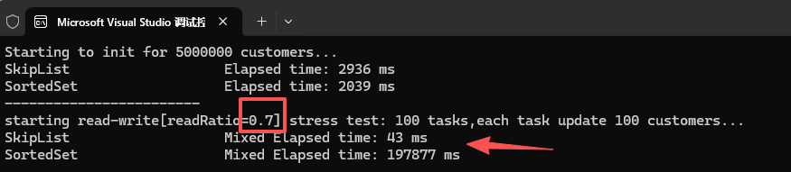
Conclusion：SkipList Outperforms SortedSet in High-Performance Ranking and Concurrent Update Scenarios

